**Unit 7**

**Advanced Microprocessors**

**(9 Hrs.)**

8086: logical block diagram and segments,

80286: Architecture, Registers, (Real/Protected mode), Privilege levels, descriptor cache, Memory access in GDT and LDT, multitasking, addressing modes, flag register

80386: Architecture, Register organization, Memory access in protected mode, Paging

**Intel 8086**

🔷 **Introduction**

* 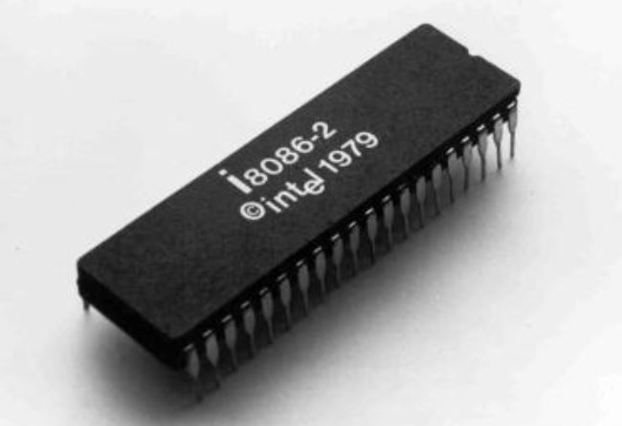The Intel 8086 is a 16-bit microprocessor developed by Intel in 1978.
* It is the successor to the 8085 microprocessor and was a major step forward in microprocessor architecture.
* It introduced pipelining, segmented memory, and 16-bit data and address buses, enabling more powerful and efficient computing.
* It became the foundation for the x86 architecture, which is still widely used in modern computing systems.

🔷 **Back with of Intel 8085 and 8086**

| **Feature** | **8085** | **8086** |
| --- | --- | --- |
| Data Bus | 8-bit | 16-bit |
| Address Bus | 16-bit (64 KB) | 20-bit (1 MB) |
| ALU Size | 8-bit | 16-bit |
| Pipelining | No | Yes |
| Registers | Fewer | More (and wider) |
| Operating Modes | Single mode | Min/Max mode |
| Memory Segmentation | No | Yes |
| Instruction Set | Basic | Advanced |

**Features of 8086**

* 16-bit data bus & 20-bit address bus
* Pipelined architecture (fetch & execute simultaneously)
* 14 registers (general-purpose, segment, pointer, index, flag)
* Operating frequency: 5 MHz (8086), 8 MHz (8086-2), 10 MHz (8086-1)
* Multiplexed address/data bus (AD0–AD15)
* Supports hardware interrupts (NMI & INTR)
* **Two modes of operation:**
  + Minimum mode (single processor)
  + Maximum mode (multiprocessor)

**Why Pipeline?**

In computing, **pipelining** improves the efficiency of instruction execution by allowing multiple instructions to overlap in execution—like an assembly line in a factory.

**Basic Concept:**

When an application runs:

**APP → List of Programs → Instructions → Process → Thread**

Each **instruction** (I) typically goes through four stages:

* **F**: Opcode Fetch
* **D**: Decode
* **E**: Execute
* **S**: Store

Let’s consider 4 instructions: **I1, I2, I3, I4**

**🔹 For Single Processor (No Pipelining):**

Each instruction is executed one after the other:

Time to execute = I1 + I2 + I3 + I4

= (F1 + D1 + E1 + S1) + (F2 + D2 + E2 + S2) +

(F3 + D3 + E3 + S3) + (F4 + D4 + E4 + S4)

= 4 ns + 4 ns + 4 ns + 4 ns

= **16 ns**

**🔹 For Parallel Processor (With Pipelining):**

Instructions are overlapped using pipeline stages:

|  |  |  |  |  |  |  |  |
| --- | --- | --- | --- | --- | --- | --- | --- |
| Time to execute = I1 + I2 + I3 + I4 | | | | | | | |
| P1 | F1 | D1 | E1 | S1 |  |  |  |
| P2 |  | F2 | D2 | E2 | S2 |  |  |
| P3 |  |  | F3 | D3 | E3 | S3 |  |
| P4 |  |  |  | F4 | D4 | E4 | S4 |
|  |  |  |  |  |  |  |  |

|  |  |  |  |  |  |  |  |
| --- | --- | --- | --- | --- | --- | --- | --- |
| **Time to execute = I1 + I2 + I3 + I4** | | | | | | | |
| **P1** | **F1** | **D1** | **E1** | **S1** |  |  |  |
| **P2** |  | **F2** | **D2** | **E2** | **S2** |  |  |
| **P3** |  |  | **F3** | **D3** | **E3** | **S3** |  |
| **P4** |  |  |  | **F4** | **D4** | **E4** | **S4** |
|  | **1** | **1** | **1** | **1** | **1** | **1** | **1** |

**Total Time = 7 cycles × 1 ns (per stage) = **7 ns\*\***

Cycle 1: F1

Cycle 2: D1 F2

Cycle 3: E1 D2 F3

Cycle 4: S1 E2 D3 F4

Cycle 5: S2 E3 D4

Cycle 6: S3 E4

Cycle 7: S4

Total Time = 7 cycles × 1 ns (per stage) = **7 ns**

**✅ Benefit of Pipelining:**

* **Non-pipelined execution:** 4 instructions → 16 ns
* **Pipelined execution:** 4 instructions → 7 ns
* **Time saved:** 9 ns
* **Efficiency increased** by overlapping instruction stages.

**Pin Diagram of the Intel 8086 Microprocessor**

**Intel 8086 Microprocessor**, which consists of **40 pins**. Each pin serves a specific function depending on whether the processor is operating in **minimum mode** (single processor system) or **maximum mode** (multiprocessor system).

**🔹 Power & Clock Pins**

* **Vcc (Pin 40)**: +5V power supply.
* **GND (Pins 1, 20)**: Ground connection.
* **CLK (Pin 19)**: Clock input. Provides timing for internal operations.
* **RESET (Pin 21)**: Resets the processor and sets program counter to zero.

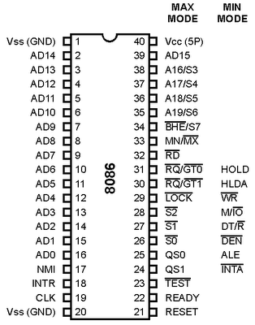

**🔹 Address/Data Bus (Multiplexed)**

* **AD0 – AD15 (Pins 2–16, 39)**:  
  These are multiplexed lines used to carry address (A0–A15) during the first part of the bus cycle and data (D0–D15) during the second part.

**🔹 Address Bus (High)**

* **A16/S3 – A19/S6 (Pins 35–38)**:  
  These are multiplexed with status signals (S3–S6) and used for addressing (A16–A19) in memory access.

**🔹 Control & Status Pins**

* **ALE (Pin 25)**: Address Latch Enable. Indicates when AD0–AD15 contains an address.
* **DEN (Pin 26)**: Data Enable. Enables the external data bus transceivers.
* **DT/R (Pin 27)**: Data Transmit/Receive. Controls direction of data flow.
* **M/IO (Pin 28)**: Distinguishes memory or I/O operation.
* **RD (Pin 32)**: Read control signal.
* **WR (Pin 29)**: Write control signal.
* **READY (Pin 22)**: Indicates if peripheral is ready for data transfer.
* **TEST (Pin 23)**: Used for synchronization with external devices.

**🔹 Interrupt Pins**

* **INTR (Pin 18)**: Interrupt request (maskable).
* **NMI (Pin 17)**: Non-maskable interrupt. Has higher priority than INTR.

**🔹 Minimum/Maximum Mode Selection**

* **MN/MX̅ (Pin 33)**:
  + Logic 1 → Minimum mode
  + Logic 0 → Maximum mode

**🔹 Minimum Mode Specific Pins**

(used only when MN/MX̅ = 1)

* **INTA (Pin 24)**: Interrupt acknowledge.
* **HOLD (Pin 31)**: DMA controller requests control of buses.
* **HLDA (Pin 30)**: DMA controller granted access to buses.
* **WR, RD, ALE, DEN, DT/R, M/IO** → Active in this mode.

**🔹 Maximum Mode Specific Pins**

(used only when MN/MX̅ = 0)

* **S2̅, S1̅, S0̅ (Pins 26–28)**: Status lines for controlling bus cycles.
* **RQ/GT1̅, RQ/GT0̅ (Pins 34, 35)**: Request/Grant for bus control in multiprocessor mode.
* **LOCK (Pin 29)**: Ensures exclusive access to shared resources.
* **QS1, QS0 (Pins 24, 25)**: Queue status signals.

**Intel 8086 architecture**

**The block diagram of the Intel 8086 architecture**, showing the **internal structure** of the microprocessor. The 8086 is divided into two main units:

1. 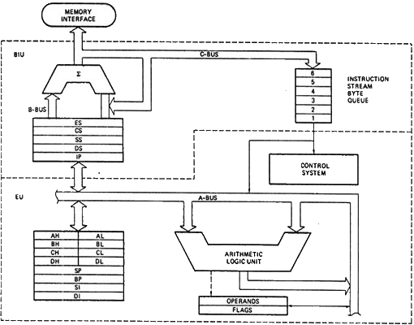**Bus Interface Unit (BIU)**
2. **Execution Unit (EU)**

**🧠 1. Bus Interface Unit (BIU)**

**Key Responsibilities:**

* Handles **address generation**, **instruction fetching**, and **communication with memory and I/O**.
* Feeds the **Execution Unit (EU)** with a stream of instructions.

**Components:**

* **Segment Registers (ES, CS, SS, DS)**  
  These hold segment addresses for Code (CS), Data (DS), Stack (SS), and Extra segment (ES).
* **Instruction Pointer (IP)**  
  Points to the next instruction in the Code Segment (CS).
* **Adder (Σ)**  
  Combines segment base and offset to form the **physical address**.
* **Instruction Queue**  
  Pre-fetches up to **6 bytes** of instructions (using pipelining). This allows the Execution Unit to execute instructions faster.
* **Memory Interface**  
  Controls the **communication between memory and processor** using the address and data buses.

**⚙️ 2. Execution Unit (EU)**

**Key Responsibilities:**

* **Decodes and executes instructions**
* Performs **arithmetic and logic operations**
* Controls flags and operands

**Components:**

* **General Purpose Registers**  
  Used for data storage and manipulation:
  + AH/AL, BH/BL, CH/CL, DH/DL → Can be used as 8-bit or combined into AX, BX, CX, DX (16-bit)
  + SP (Stack Pointer), BP (Base Pointer), SI (Source Index), DI (Destination Index)
* **Arithmetic and Logic Unit (ALU)**  
  Performs all **arithmetic (add, subtract, etc.)** and **logic (AND, OR, NOT, etc.)** operations.
* **Operands and Flags**
  + **Operands**: Data inputs to the ALU.
  + **Flags**: Special-purpose bits reflecting the outcome of ALU operations (e.g., Zero, Carry, Overflow).

**🔄 Data Buses:**

* **A-Bus**:  
  Transfers data between **registers and ALU** in the Execution Unit.
* **C-Bus**:  
  Transfers **addresses and instructions** from the BIU to memory and instruction queue.

**⛓️ Summary:**

| **Component** | **Purpose** |
| --- | --- |
| BIU | Handles memory interaction, instruction fetching |
| Segment Registers | Holds memory segment addresses |
| Instruction Pointer | Points to next instruction |
| Instruction Queue | Stores pre-fetched instructions (6 bytes max) |
| EU | Executes instructions using ALU |
| General Registers | Temporary storage and data manipulation |
| ALU | Arithmetic and logic processing |
| Flags | Reflect results of operations |
| A-Bus, C-Bus | Internal data and control signal pathways |

**Registers in 8086**

General Purpose Registers (8)

Pointer and Index Registers (4)

Segment Registers (4)

Instruction Pointer (IP)

Flag Register (1 total)

**A. General Purpose Registers (8)**

Used for arithmetic, logic, data transfer operations.

| **Register** | **16-bit** | **8-bit Parts** | **Usage** |
| --- | --- | --- | --- |
| AX | AH + AL | AH, AL | Accumulator |
| BX | BH + BL | BH, BL | Base register |
| CX | CH + CL | CH, CL | Counter (loops, shifts) |
| DX | DH + DL | DH, DL | Data register (I/O, MUL/DIV) |

B. **Pointer and Index Registers (4)**

| **Register** | **Function** |
| --- | --- |
| SP | Stack Pointer |
| BP | Base Pointer |
| SI | Source Index (used in string operations) |
| DI | Destination Index |

**C. Segment Registers (4)**

Used to access different memory segments (20-bit address space)

| **Register** | **Segment** |
| --- | --- |
| CS | Code Segment (for IP) |
| DS | Data Segment |
| SS | Stack Segment |
| ES | Extra Segment |

🔸 *These segment registers hold the base addresses used to compute the 20-bit physical address.*

**D. Instruction Pointer (IP)**

* Holds offset of the next instruction in the **code segment (CS)**.

**E. Flag Register (1 total)**

* 16-bit register with 9 active flags (explained below)

**Physical Address Calculation in 8086**

8086 uses **Segment: Offset** addressing, combining **a 16-bit segment register** and **a 16-bit offset** to form a **20-bit physical address**.

**Physical Address = (Segment × 10h) + Offset**

**Example:** Let’s say:

Segment = 1234h Offset = 0010h

Then,

**Physical Address** = (1234h × 10h) + 0010h

= 12340h + 0010h

= **12350h**

**Flags Register in 8086 (16-bit)**

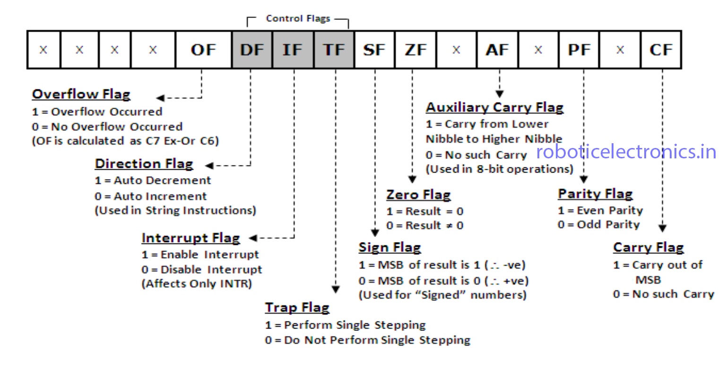

**A. Status Flags**

Indicate results of operations:

* **CF** – Carry Flag
* **PF** – Parity Flag
* **AF** – Auxiliary Carry Flag
* **ZF** – Zero Flag
* **SF** – Sign Flag
* **OF** – Overflow Flag

**B. Control Flags**

Control processor operations:

* **TF** – Trap Flag (for debugging)
* **IF** – Interrupt Enable Flag
* **DF** – Direction Flag (string operations)

**Addressing Modes in 8086**

An **addressing mode** specifies **how an operand (data)** for an instruction is accessed (i.e., whether it is in a register, memory, or part of the instruction itself).

8086 supports **several addressing modes** to allow flexible memory and data access.

**1. Immediate Addressing Mode**

* The operand is directly specified in the instruction.
* Data is given as a **constant value**.

**MOV AX, 1234h ; AX ← 1234h**

**Use:** Simple data loading.

**2. Register Addressing Mode**

* The operand is located in a **register**.
* Both source and destination are registers.

**MOV AX, BX ; AX ← BX**

**Use:** Fast data movement within CPU.

**3. Direct Addressing Mode**

* The **memory address** of the operand is **given explicitly** in the instruction.
* Offset is fixed; segment is usually **DS** by default.

**MOV AX, [1234h] ; AX ← contents at memory address DS:1234h**

**Use:** Access fixed memory location.

**4. Register Indirect Addressing Mode**

* The **effective address** of the operand is stored in a register.
* Registers used: **BX**, **BP**, **SI**, or **DI**.
* Segment: **DS** for BX, SI, DI; **SS** for BP.

**MOV AX, [BX] ; AX ← contents at DS:BX**

**Use:** Access variable memory locations dynamically.

**5. Based Addressing Mode**

* A **base register** holds the offset (BX or BP).
* Optional displacement can be added.
* Segment: **DS** (for BX), **SS** (for BP)

**MOV AX, [BP] ; AX ← contents at SS:BP**

**Use:** Access stack or data memory.

**6. Indexed Addressing Mode**

* Uses index registers: **SI** or **DI**
* Effective address = contents of index register
* Segment default: **DS**

**MOV AX, [SI] ; AX ← contents at DS:SI**

**Use:** Access array elements.

**7. Based-Indexed Addressing Mode**

* Combines base register (BX or BP) and index register (SI or DI).
* Effective address = base + index
* Segment default: **DS** or **SS** depending on base

**MOV AX, [BX + SI] ; AX ← contents at DS:(BX+SI)**

**Use:** Multidimensional arrays or struct access.

**8. Based-Indexed with Displacement**

* Most flexible addressing mode.
* Effective address = base + index + displacement
* Allows full offset control.

**MOV AX, [BX + SI + 10] ; AX ← contents at DS:(BX + SI + 10)**

**Use:** Array element + offset access.

**9. Relative Addressing Mode**

Used **only with jump (JMP) and branch instructions**.

* The target address is relative to the **current instruction pointer (IP)**.

**JMP SHORT LABEL ; IP ← IP + displacement to LABEL**

**Use:** Efficient code branching.

| **Mode** | **Syntax Example** | **Effective Address Formula** |
| --- | --- | --- |
| Immediate | MOV AX, 1234h | Operand is in instruction |
| Register | MOV AX, BX | Operand in register |
| Direct | MOV AX, [1234h] | EA = 1234h |
| Register Indirect | MOV AX, [BX] | EA = contents of BX |
| Based | MOV AX, [BP] | EA = BP |
| Indexed | MOV AX, [SI] | EA = SI |
| Based + Indexed | MOV AX, [BX + SI] | EA = BX + SI |
| Based + Indexed + Disp | MOV AX, [BX + SI + 5] | EA = BX + SI + 5 |
| Relative (Jumps only) | JMP SHORT LABEL | New IP = Old IP + displacement |

**Programming with 8085**

Software Simulator: <https://github.com/sanjeevlcc/notes_2081/blob/main/Microprocessor_and_CA/TU%20BSC-CSIT%20Microprocessor/emu8086v408.zip>

**After Running program**

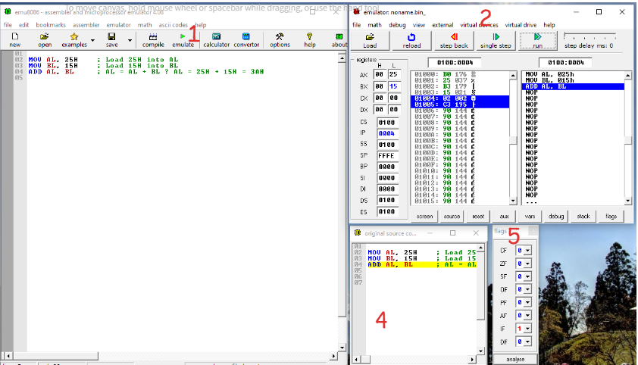

**Sample 8086 Addition**

**Addition (8-bit)**

MOV AL, 25H ; Load 25H into AL

MOV BL, 15H ; Load 15H into BL

ADD AL, BL ; AL = AL + BL → AL = 25H + 15H = 3AH

**Subtraction (8-bit)**

MOV AL, 25H ; Load 25H into AL

MOV BL, 15H ; Load 15H into BL

SUB AL, BL ; AL = AL - BL → AL = 25H - 15H = 10H

**Addition (16-bit)**

MOV AX, 1234H ; Load 1234H into AX

MOV BX, 1111H ; Load 1111H into BX

ADD AX, BX ; AX = AX + BX → AX = 1234H + 1111H = 2345H

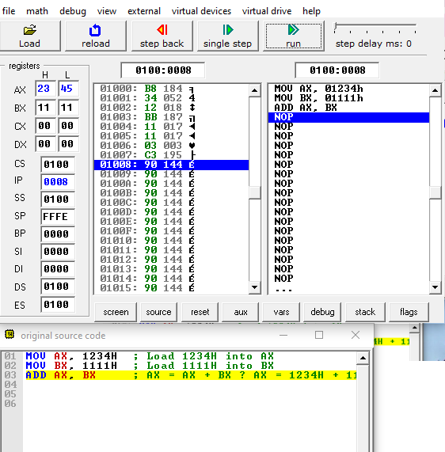

**Subtraction (16-bit)**

MOV AX, 1234H ; Load 1234H into AX

MOV BX, 1111H ; Load 1111H into BX

SUB AX, BX ; AX = AX - BX → AX = 1234H - 1111H = 0123H

**Multplication (8-bit)**

MOV AL, 05H ; AL = 5

MOV BL, 04H ; BL = 4

MUL BL ; Unsigned multiplication: AL × BL → result in AX

; Result: AL = 14H (20 decimal), AH = 00H (no overflow)

**Division (8-bit)**

MOV AL, 14H ; AL = 20

MOV BL, 04H ; BL = 4

DIV BL ; Unsigned division: AX / BL → quotient in AL, remainder in AH

; Quotient: AL = 05H, Remainder: AH = 00H

**Multplication (16-bit)**

MOV AX, 0012H ; AX = 0012H (18 decimal)

MOV BX, 0003H ; BX = 0003H (3 decimal)

MUL BX ; Unsigned multiplication: AX × BX → result in DX:AX

; Result: AX = 0036H (54), DX = 0000H (no overflow)

**Division (16-bit)**

MOV AX, 0037H ; Dividend low word

MOV DX, 0000H ; Dividend high word (clear DX)

MOV BX, 0003H ; Divisor = 3

DIV BX ; Unsigned division: DX:AX / BX

; Quotient: AX = 0012H (0B), Remainder: DX = 0001H

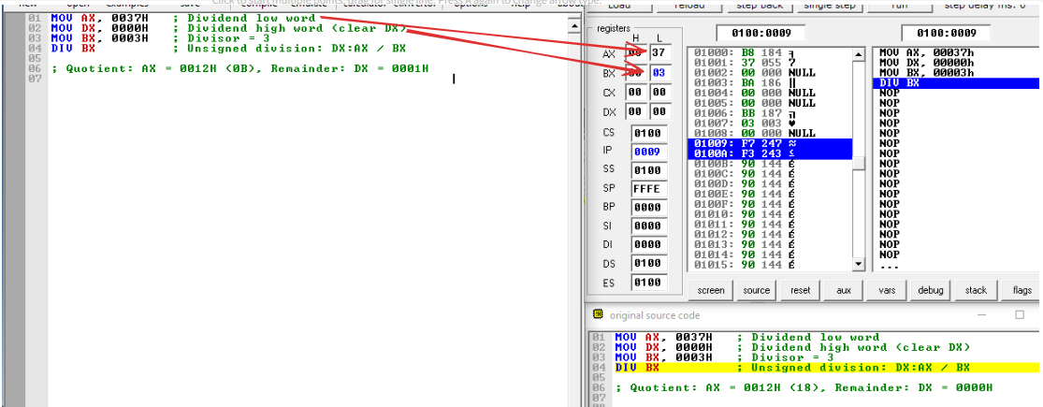

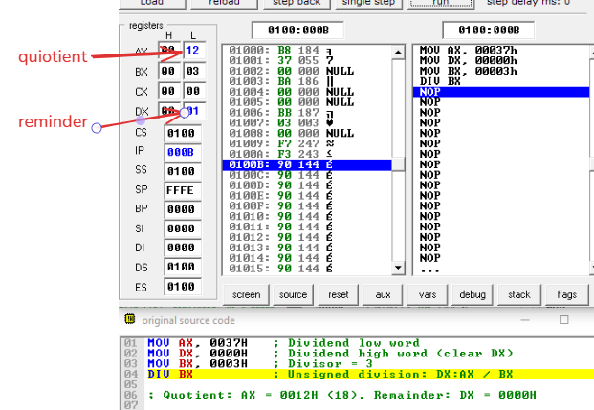

**Simple “Hello World” Program**

**.MODEL SMALL**

**.STACK 100H**

**.DATA**

**MSG DB 'Hello, World!$' ; Message ends with '$' for DOS string termination**

**.CODE**

**MAIN:**

**MOV AX, @DATA**

**MOV DS, AX ; Initialize data segment**

**LEA SI, MSG ; Load offset of MSG into SI**

**PRINT_LOOP:**

**MOV AL, [SI] ; Load character from MSG into AL**

**CMP AL, '$' ; Check for end of string**

**JE EXIT ; If '$', exit loop**

**MOV DL, AL ; Move character to DL**

**MOV AH, 02H ; DOS function: print character**

**INT 21H ; Call DOS interrupt**

**INC SI ; Move to next character**

**JMP PRINT_LOOP ; Repeat**

**EXIT:**

**MOV AH, 4CH ; DOS terminate program**

**INT 21H**

**END MAIN**

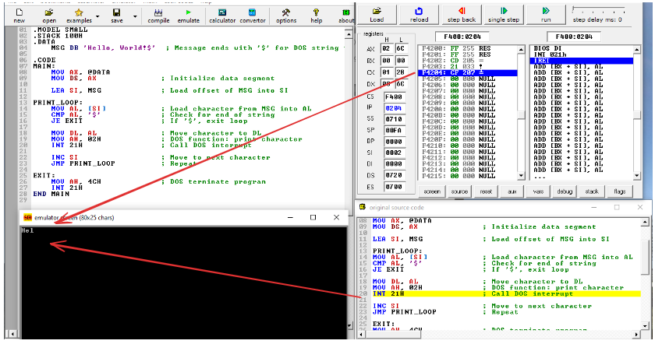

**OR**

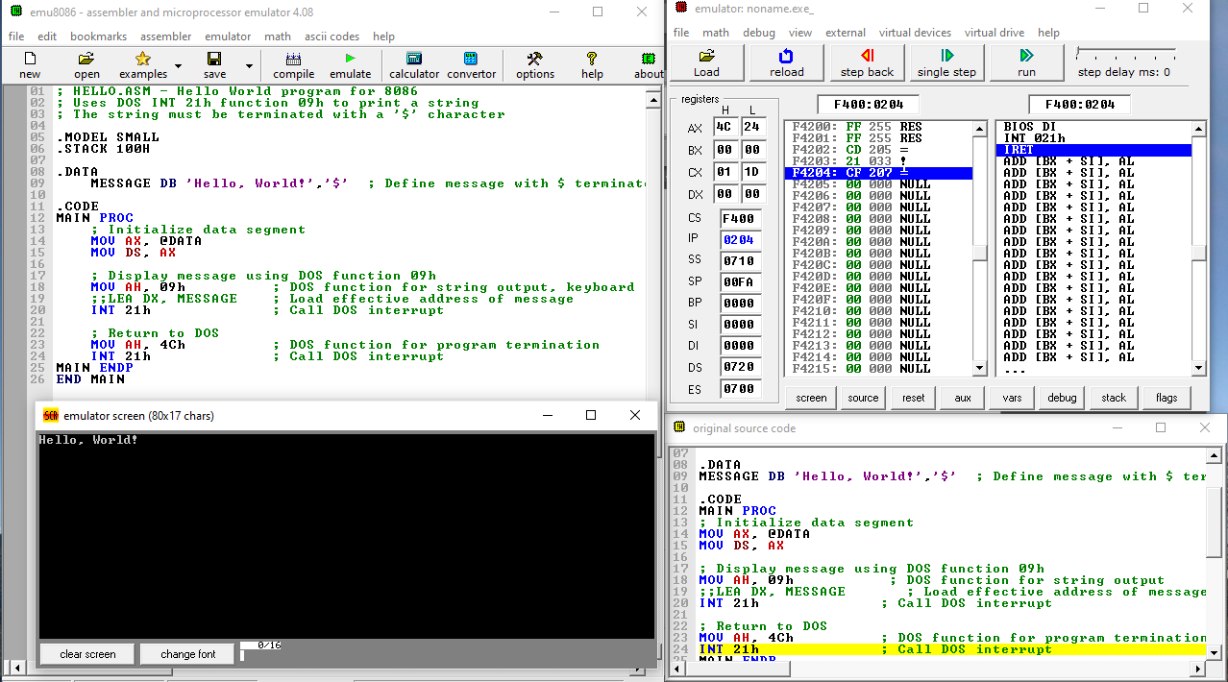

*; HELLO.ASM - Hello World program for 8086*

*; Uses DOS INT 21h function 09h to print a string*

*; The string must be terminated with a '$' character*

*.MODEL SMALL*

*.STACK 100H*

*.DATA*

*MESSAGE DB 'Hello, World!','$' ; Define message with $ terminator*

*.CODE*

*MAIN PROC*

*; Initialize data segment*

*MOV AX, @DATA*

*MOV DS, AX*

*; Display message using DOS function 09h*

*MOV AH, 09h ; DOS function for string output, keyboard*

*;;LEA DX, MESSAGE ; Load effective address of message*

*INT 21h ; Call DOS interrupt*

*; Return to DOS*

*MOV AH, 4Ch ; DOS function for program termination*

*INT 21h ; Call DOS interrupt*

*MAIN ENDP*

*END MAIN*

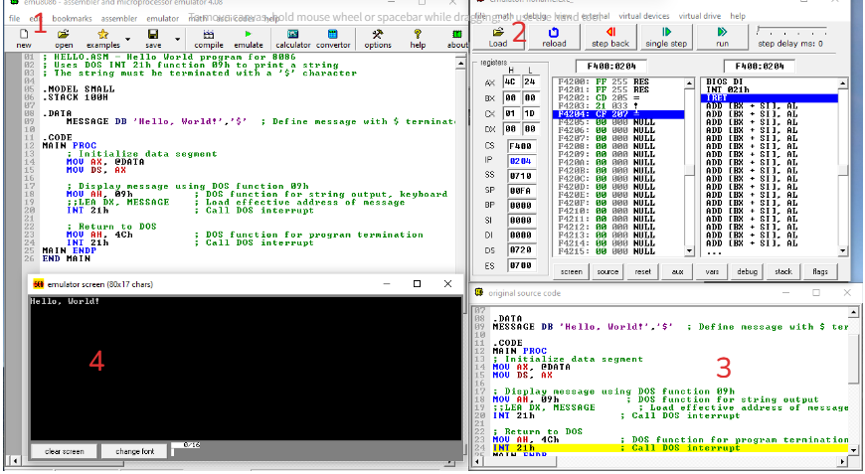

**Palindrome**

***.MODEL SMALL***

***.STACK 100H***

***.DATA***

***; Define the test string (you can change this)***

***STRING DB 'MADAM', '$' ; String to check (must be uppercase)***

***STR_LEN EQU 5 ; Length of the string (excluding $)***

***; Output messages***

***MSG_YES DB 'Palindrome$', 0***

***MSG_NO DB 'Not Palindrome$', 0***

***.CODE***

***MAIN PROC***

***; Set up segments***

***MOV AX, @DATA***

***MOV DS, AX***

***; Setup SI and DI to compare characters***

***LEA SI, STRING ; SI -> start of the string***

***LEA DI, STRING***

***ADD DI, STR_LEN - 1 ; DI -> end of the string (before $)***

***MOV CX, STR_LEN / 2 ; Number of comparisons (half length)***

***MOV BX, 0 ; BX = mismatch flag***

***CHECK_LOOP:***

***MOV AL, [SI]***

***MOV DL, [DI]***

***CMP AL, DL***

***JNE NOT_PALINDROME***

***INC SI***

***DEC DI***

***LOOP CHECK_LOOP***

***; If no mismatches found***

***LEA DX, MSG_YES***

***JMP PRINT_RESULT***

***NOT_PALINDROME:***

***LEA DX, MSG_NO***

***PRINT_RESULT:***

***MOV AH, 09H ; DOS function to print string***

***INT 21H***

***; Exit program***

***MOV AH, 4CH***

***INT 21H***

***MAIN ENDP***

***END MAIN***

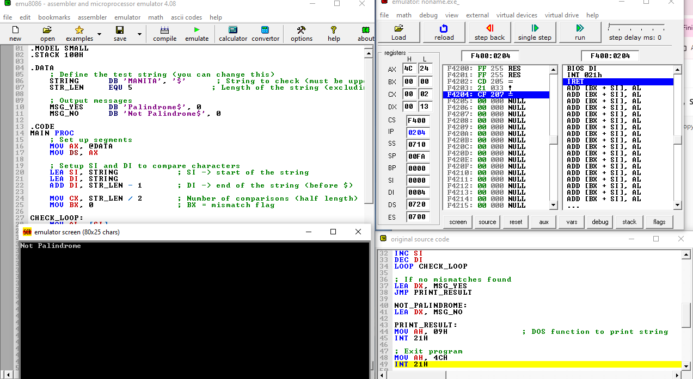

**Subtraction (16-bit)**

**80286: Architecture, Registers, (Real/Protected mode), Privilege levels, descriptor cache, Memory access in GDT and LDT, multitasking, addressing modes, flag register**

**✅ Summary Table**

| **Bus Type** | **Width** | **Direction** | **Purpose** |
| --- | --- | --- | --- |
| **Address** | 24-bit | Unidirectional | Specifies memory/I/O addresses |
| **Data** | 16-bit | Bidirectional | Transfers data and instructions |
| **Control** | Varies | Mixed | Controls operations like read/write |

| **Feature** | **Description** |
| --- | --- |
| Address Bus | 24-bit → 16MB memory |
| Real Mode | 8086-compatible, 1MB memory, no protection |
| Protected Mode | Enables multitasking, memory protection |
| GDT/LDT | Define memory segments for system and tasks |
| Multitasking | Through Task State Segment and task descriptors |
| Descriptor Cache | Internal registers holding descriptor info |
| Privilege Levels | 0 (kernel) to 3 (user) security levels |
| Flags Register | Status and control flags for arithmetic, execution |

|  |
| --- |
| **✅ 1. Address Bus**  **🔹 Definition:**   * The **Address Bus** is used by the processor to **specify memory addresses** or **I/O ports** to read from or write to.   **🔹 Key Features:**   * **Width:** **24-bit** address bus * **Addressable Memory:** **2²⁴ = 16 MB** of physical memory * **Unidirectional:** Data flows only **from CPU to memory/I/O**   **🔹 Use:**   * Sends memory addresses to RAM, ROM, or I/O devices. |
| **✅ 2. Data Bus**  **🔹 Definition:**   * The **Data Bus** carries actual **data values** between the CPU, memory, and I/O devices.   **🔹 Key Features:**   * **Width:** **16-bit** data bus * **Bidirectional:** Data flows **both ways** (to and from the CPU)   **🔹 Use:**   * Transfers instructions, operand values, and I/O data. * 16 bits at a time → suitable for word operations. |
| **✅ 3. Control Bus**  **🔹 Definition:**   * The **Control Bus** carries **control signals** that manage and coordinate all CPU activities.  | **Signal** | **Description** | | --- | --- | | **RD̅** | Read – Memory or I/O read operation | | **WR̅** | Write – Memory or I/O write operation | | **ALE** | Address Latch Enable – Separates address/data | | **DT/R̅** | Data Transmit/Receive – Bus direction | | **DEN̅** | Data Enable – Enables external data bus | | **READY** | Wait state insertion from slow devices | | **INTA̅** | Interrupt Acknowledge | | **NMI** | Non-maskable interrupt | | **LOCK** | Locks system bus for atomic operations | | **HOLD/HLDA** | Bus control for DMA | |

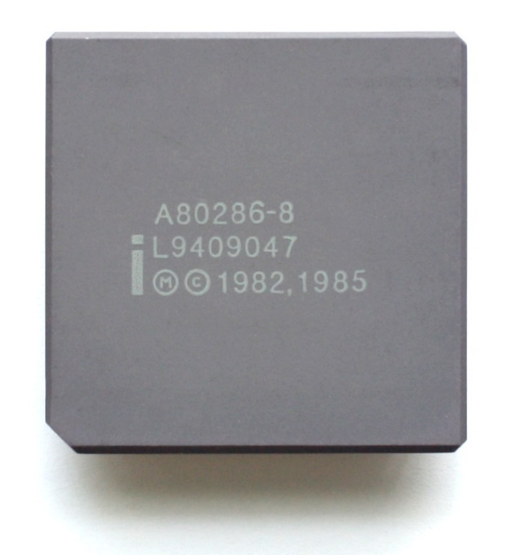**✅ 1. Architecture Overview**

* Introduced by Intel in **1982**, 80286 (or iAPX 286) is a **16-bit** microprocessor.
* Clock speed: 6 MHz – 25 MHz.
* **24-bit address bus** → Can address up to **16 MB of physical memory**.
* Supports **Real Mode** (8086-compatible) and **Protected Mode** (advanced features).

**✅ 2. Registers of 80286**

**🔹 General-Purpose Registers (16-bit):**

* 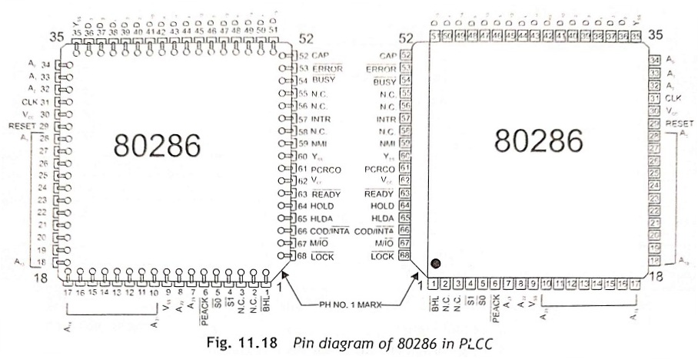AX (Accumulator)
* BX (Base)
* CX (Count)
* DX (Data)

**🔹 Segment Registers:**

* CS (Code Segment)
* DS (Data Segment)
* SS (Stack Segment)
* ES (Extra Segment)

**🔹 Pointer and Index Registers:**

* SP (Stack Pointer), BP (Base Pointer)
* SI (Source Index), DI (Destination Index)

**🔹 Instruction Pointer and Flags:**

* IP (Instruction Pointer)
* FLAGS (Status and control bits)

**✅ 3. Real Mode vs Protected Mode**

| **Feature** | **Real Mode** | **Protected Mode** |
| --- | --- | --- |
| Addressable Memory | 1 MB (20-bit addressing) | 16 MB physical, 1 GB virtual memory |
| Mode Type | Compatible with 8086 | Advanced features enabled |
| Multitasking | Not supported | Supported |
| Protection | None | Memory protection, privilege levels |
| Switching | Default on reset | Entered by setting PE (CR0 bit 0) |

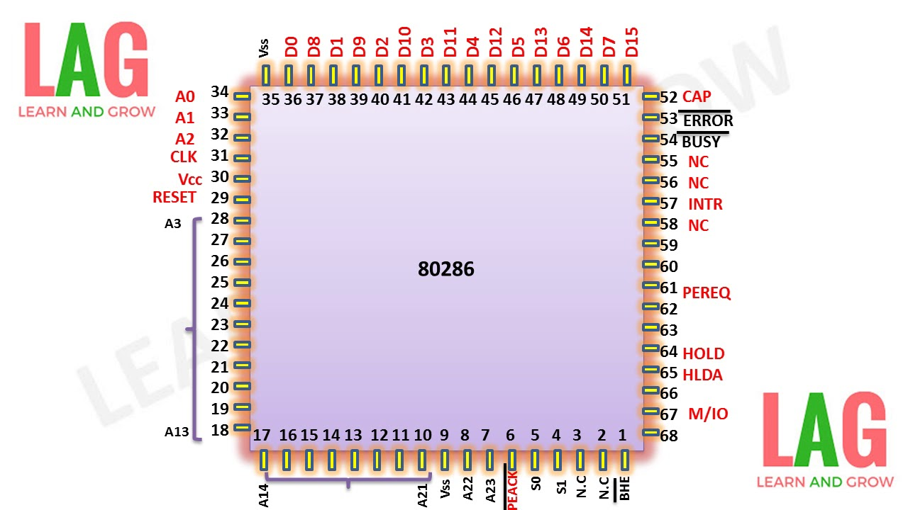**✅ 4. Privilege Levels**

* **4 Privilege Levels (Ring 0 to Ring 3)**:
  + **Ring 0**: Most privileged (Kernel/OS)
  + **Ring 3**: Least privileged (User apps)
* Used for **memory and I/O protection**.
* **CPL (Current Privilege Level)** vs **DPL (Descriptor Privilege Level)**.

**✅ 5. Descriptor Cache (Shadow Registers)**

* Internal registers that **store segment descriptor info** (base, limit, access rights) from memory.
* When a segment is loaded (e.g., MOV DS, AX), the CPU fetches the **descriptor from GDT/LDT** and stores in **descriptor cache**.
* Fast access to segment properties without repeatedly accessing memory.

**✅ 6. Memory Access with GDT and LDT**

**🔹 Global Descriptor Table (GDT)**

* System-wide table with **segment descriptors**.
* Each entry defines: Base address, Limit, Access rights.
* Used for **code, data, stack segments**, etc.

**🔹 Local Descriptor Table (LDT)**

* Specific to **each task/process**.
* Defines memory accessible to that task.
* Enables task isolation and memory protection.

**✅ 7. Multitasking**

* 80286 supports **hardware-level multitasking** using the **Task State Segment (TSS)**.
* Each task has:
  + Own **register set**, **LDT**, **stack**, **flags**.
  + Described using a **Task Descriptor** in GDT.
* **Task Switching** involves:
  + Saving current task state to its TSS.
  + Loading new task state from next TSS.
  + Updating Task Register and control flags.

**✅ 8. Addressing Modes in 80286**

Supports all 8086 addressing modes:

**🔹 Register and Immediate Modes:**

* MOV AX, BX
* ADD AX, 1234H

**🔹 Memory Addressing Modes:**

* **Direct**: [1234H]
* **Register Indirect**: [BX], [SI], [DI]
* **Based**: [BX+SI], [BX+DI]
* **Based Indexed + Displacement**: [BX+SI+10H]

→ Uses **Effective Address (EA)** computation:  
EA = Base + Index + Displacement

**✅ 9. Flag Register (FLAGS)**

| **Bit** | **Flag Name** | **Description** |
| --- | --- | --- |
| 0 | CF (Carry) | Carry out from MSB |
| 2 | PF (Parity) | Set if even number of 1’s in LSB |
| 4 | AF (Auxiliary) | Carry from bit 3 to bit 4 |
| 6 | ZF (Zero) | Set if result is zero |
| 7 | SF (Sign) | Set if result is negative |
| 8 | TF (Trap) | Enables single-step mode |
| 9 | IF (Interrupt) | Enables/disables hardware interrupts |
| 10 | DF (Direction) | Controls string operation direction |
| 11 | OF (Overflow) | Set if signed overflow occurs |

**Intel 80386 Microprocessor**

***Architecture***

***Register organization***

***Memory access in protected mode***

***Paging***

| **Feature / Processor** | **8086** | **80186** | **80286** | **80386** |
| --- | --- | --- | --- | --- |
| **Year Introduced** | 1978 | 1982 | 1982 | 1985 |
| **Architecture** | 16-bit | 16-bit | 16-bit | 32-bit |
| **Data Bus Width** | 16-bit | 16-bit | 16-bit | 32-bit |
| **Address Bus Width** | 20-bit (1 MB memory) | 20-bit (1 MB memory) | 24-bit (16 MB memory) | 32-bit (4 GB memory) |
| **Clock Speed (typical)** | 5 – 10 MHz | 6 – 10 MHz | 6 – 25 MHz | 12 – 40 MHz |
| **Instruction Set** | Basic x86 | 8086 + extended instructions | 8086 + Protected Mode | Full x86 + **paging** and 32-bit ops |
| **Registers** | 16-bit general-purpose | Same as 8086 | Same as 8086 | 32-bit registers (EAX, EBX, etc.) |
| **Operating Modes** | Real Mode only | Real Mode only | Real Mode, Protected Mode | Real, Protected, **and Virtual 8086 Mode** |
| **Segmentation Support** | Yes | Yes | Yes | Yes + Descriptor Tables |
| **Paging Support** | No | No | No | **Yes** (2-level) |
| **Virtual Memory** | No | No | Limited (segment-based) | **Yes** (paging-based) |
| **Multitasking Support** | No | No | Partial (via TSS) | **Yes** (hardware support) |
| **Integrated Peripherals** | No | **Yes** (timer, DMA, interrupt) | No | No |
| **Memory Protection** | No | No | **Yes** (via segment descriptors) | **Yes** (segment + page protection) |
| **Privilege Levels** | None | None | **4 levels (0–3)** | **4 levels (0–3)** |
| **Real Mode Compatibility** | Native | Native | Compatible | Compatible |
| **Applications** | Early PCs | Embedded systems | Early multitasking OSs | Advanced OSs, multitasking systems |

**1. Architecture of 80386**

* The **Intel 80386** is a **32-bit microprocessor** introduced in 1985.
* It supports **multitasking**, **memory protection**, and **virtual memory**.
* Operates in three modes:
  + **Real Mode** (8086 compatible)
  + **Protected Mode** (advanced mode with full features)
  + **Virtual 8086 Mode** (for multitasking legacy software)

**🔷 Architectural Highlights:**

* 32-bit **data** and **address** bus.
* Can address **4 GB** of physical memory (2³²).
* Supports **segmentation** and **paging**.
* Internal pipelining for faster execution.
* Integrated **Memory Management Unit (MMU)**.
* Clock speed: 12–40 MHz.

**2. Register Organization in 80386**

Intel 80386 is a **32-bit microprocessor** with an **enhanced register set** over 8086/80286, supporting both **16-bit and 32-bit** operations. The registers are categorized into:

**🔹 1. General Purpose Registers (GPRs)**

These are used for arithmetic, logical operations, data movement, and addressing. Each 32-bit register is **backward compatible** with its 16-bit and 8-bit counterparts.

| **32-bit** |  | **16-bit** | **8-bit High** | **8-bit Low** |
| --- | --- | --- | --- | --- |
| EAX | **EAX**: Accumulator (used in arithmetic) | AX | AH | AL |
| EBX | **EBX**: Base register (often used in memory addressing) | BX | BH | BL |
| ECX | **ECX**: Counter (used in loops, shift/rotate) | CX | CH | CL |
| EDX | **EDX**: Data register (used with EAX in multiplication/division) | DX | DH | DL |
| ESI | **ESI/EDI**: Source/Destination Index (used in string operations) | SI | – | – |
| EDI |  | DI | – | – |
| EBP | **EBP**: Base Pointer (for stack frame access) | BP | – | – |
| ESP | **ESP**: Stack Pointer (points to top of the stack) | SP | – | – |

**🔸 b. Segment Registers (16-bit):**

Used to select segments (Code, Data, Stack, Extra) via descriptors.

* **CS**: Code Segment
* **DS**: Data Segment
* **SS**: Stack Segment
* **ES**: Extra Segment
* **FS, GS**: Additional segments (used for OS/multitasking)

These are used with **segment selectors** to access memory via the **descriptor tables** in Protected Mode.

**🔸 c. Instruction Pointer:**

**EIP (Extended Instruction Pointer):**32-bit register that holds the offset address of the next instruction to be executed.

**🔸 d. Flags Register:**

Stores status flags, control flags, and system flags.

**Common Flags:**

* CF – Carry Flag
* PF – Parity Flag
* AF – Auxiliary Carry
* ZF – Zero Flag
* SF – Sign Flag
* TF – Trap Flag
* IF – Interrupt Enable Flag
* DF – Direction Flag
* OF – Overflow Flag

Additional system flags support virtual memory and protection.

**🔸 e. Control Registers (CR0–CR3):**

Used to control the **processor mode**, enable/disable **paging**, and manage **memory protection**.

| **Register** | **Purpose** |
| --- | --- |
| **CR0** | Enables Protected Mode (bit 0 = PE), Paging (bit 31 = PG) |
| **CR2** | Stores the linear address that caused a page fault |
| **CR3** | Holds the base address of the Page Directory (used in paging) |

**🔸 f. System Descriptor Registers:**

Used for **memory segmentation** and **interrupt handling** in Protected Mode.

| **Register** | **Purpose** |
| --- | --- |
| **GDTR** | Global Descriptor Table Register – base and limit of GDT |
| **LDTR** | Local Descriptor Table Register – for tasks |
| **IDTR** | Interrupt Descriptor Table Register – base/limit of IDT |
| **TR** | Task Register – points to Task State Segment (TSS) |

**🔹 7. Debug and Test Registers (Advanced Use)**

* DR0–DR7: Debug Registers – for hardware breakpoints.
* TR6–TR7: Test Registers – used internally for cache testing.

**✅ 3. Memory Access in Protected Mode (Intel 80386)**

**🔹 What is Protected Mode?**

Protected Mode is an **advanced operating mode** of the Intel 80386 (and 80286+) that supports:

* Full **32-bit memory addressing**
* **Multitasking**
* **Memory protection**
* **Virtual memory** via **segmentation and paging**

It allows access to the **entire 4 GB address space** using segmentation and optional paging.

**🔹 Memory Access Mechanism in Protected Mode**

Memory access in protected mode is done in **three steps**:

**🔸 Step 1: Logical Address = Segment Selector + Offset**

* The **logical address** provided by the program consists of:
  + A **segment selector** (16-bit)
  + A **logical offset** (32-bit)
* The **segment selector** identifies an entry in either:
  + **Global Descriptor Table (GDT)**
  + **Local Descriptor Table (LDT)**

**🔸 Step 2: Selector → Descriptor → Linear Address**

* The segment selector is used to **index into GDT/LDT** to get the **segment descriptor**.
* The **segment descriptor** contains:
  + **Base Address** (32-bit)
  + **Limit** (size of the segment)
  + **Access Rights** (read, write, execute, privilege level)
* The **Base Address** from the descriptor is added to the **offset** to form the **Linear Address**.

*Linear Address = Base (from descriptor) + Offset*

**🔸 Step 3 (Optional): Linear Address → Physical Address (via Paging)**

* If **paging is enabled**, the **linear address** is translated to a **physical address** using:
  + **Page Directory** (pointed to by CR3)
  + **Page Tables**

Otherwise, the **linear address is used directly** as the physical address.

**🔹 Example Summary Flow**

**Logical Address = Selector + Offset**

**↓**

**Use Selector → GDT/LDT → Descriptor**

**↓**

**Get Base Address → Add Offset → Linear Address**

**↓**

**(Optional) Linear Address → Paging → Physical Address**

**4. Paging in 80386**

**🔹 What is Paging?**

**Paging** is a memory management scheme that allows the operating system to:

* Use **virtual memory**
* Divide memory into fixed-size **pages**
* Isolate processes
* Protect memory from illegal access

In **80386**, paging can be used **with or without segmentation**, and provides a way to map **linear addresses to physical addresses**.

**🔹 Key Features of Paging in 80386**

* **Page size**: 4 KB (4096 bytes)
* **Addressable memory**: 4 GB
* **Two-level paging structure**
* Enables **virtual memory** and **process isolation**
* Controlled via **Control Registers** (CR0, CR3)

**🔹 Address Translation in Paging**

80386 uses a **2-level page table** to translate a **32-bit linear address** into a **physical address**.

**🧠 Breakdown of 32-bit Linear Address:**

| **Bits** | **Used For** |
| --- | --- |
| 31–22 | Page Directory Index (10 bits) |
| 21–12 | Page Table Index (10 bits) |
| 11–0 | Offset within page (12 bits) |

**🔸 Paging Data Structures**

**a. Page Directory (1024 entries)**

* Each entry points to a **Page Table**
* Size: 4 bytes per entry × 1024 = 4 KB

**b. Page Tables (1024 entries each)**

* Each entry points to a **4 KB Page Frame** in physical memory
* Size: 4 bytes per entry × 1024 = 4 KB

**c. Page Frame**

* The actual **physical memory block** (4 KB) that stores data

**🔸 Address Translation Process**

1. **CR3** holds the **base address of Page Directory**
2. Extract bits from the linear address:
   * Bits 31–22: Page Directory Index → Get Page Table Address
   * Bits 21–12: Page Table Index → Get Page Frame Address
   * Bits 11–0: Offset → Final Byte within Page Frame
3. Combine Page Frame Base + Offset → **Physical Address**

**📌 Summary:**

**Linear Address (32-bit)**

**↓**

**[Directory Index] → Page Directory → Page Table**

**↓**

**[Table Index] → Page Table Entry → Page Frame**

**↓**

**[Offset] → Final Byte in Physical Memory**

**🔸 Enabling Paging in 80386**

Paging is enabled by setting:

* **Bit 31 (PG)** of **CR0** to 1 (Paging Enable)
* CR3 must point to the **Page Directory Base**

**Example (in conceptual pseudo-code)**

MOV CR3, PageDirectoryBase

SET CR0.PG = 1 ; Enable Paging

**🔹 Advantages of Paging**

| **Benefit** | **Description** |
| --- | --- |
| **Virtual Memory** | Allows programs to use more memory than RAM |
| **Protection** | Isolates processes; prevents memory leaks |
| **Efficiency** | Allocates only used memory in 4 KB chunks |
| **Swapping** | Enables demand paging & page swapping |

**🔹 Comparison with Segmentation**

| **Feature** | **Segmentation** | **Paging** |
| --- | --- | --- |
| Division Type | Logical (varied-size segments) | Physical (fixed-size pages) |
| Addressing | Selector + Offset | Linear → Physical (via tables) |
| Flexibility | Better for logical structures | Better for virtual memory |

**✅ Summary Table:**

| **Feature** | **Description** |
| --- | --- |
| Address Bus | 32-bit (4 GB addressable) |
| Modes | Real, Protected, Virtual 8086 |
| Key Registers | EAX–EDI, EIP, EFLAGS, Segment Registers |
| Control Registers | CR0–CR3 |
| Memory Mgmt | Segmentation + Paging |
| Paging Unit | Two-level (Page Directory + Page Table) |
| Page Size | 4 KB |